**Source is fictional**



Nature Photos

www.naturephoto.ca/lion

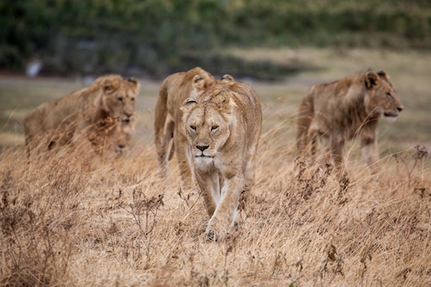

Lions on the Savannah

Kris Burlingame, 2001

X